Pre-test and post test applied to children and the cooperate teacher

QUESTIONNAIRE TO CHILDREN IN THE CLASS
Please read the following questions carefully. Remember: This is not a test, so there are no wrong answers and all are possible. Your opinion is important and you will register it at various times: before you start and after carrying out a project on “Trash Value” (Egg boxes).
Thank you very much for your participation!

Let's start …
Gender: Female Male

REASONING AND MATHEMATICAL COMMUNICATION
When I solve math problems ...
 | I feel like I'm able to ... | Rarely | sometimes | Oftentimes | Ever
PROBLEM ACTION | be creative in an idea to find the solution to the problem
PROBLEM ACTION | be creative in applying that idea
PROBLEM ACTION | explain my reasoning
PROBLEM ACTION | justify my reasoning
PROBLEM ACTION | argue (defend the idea)
PROBLEM ACTION | generalize (apply knowledge prior to solving the new problem)
PROBLEM ACTION | be objective (aim to solve the problem)
SELF REFLECTION | Reflect if…
SELF REFLECTION | the solution found is the correct answer to the problem
SELF REFLECTION | there are other solutions
SELF REFLECTION | there are other resolution strategies that can be applied
SELF REFLECTION | I was able to understand the process of solving the problem, from the idea to the discovery of the solution

Please register in this space other information / ideas to better understand your answers.

SOCIAL COMPETENCES
When I work in a group I feel that I am capable of….
Competences | Observable behavior | Rarely | sometimes | Oftentimes | Ever
COMMUNICATION | make me understand
ASSERTIVENESS | be objective
SELF-CONTROL | control what I feel
SELF-CONTROL | control what I do
CRIATIVITY | Have ideas
RESPONSABILITY | become aware of the risks
RESPONSABILITY | assume the fulfillment of tasks
COOPERATION | respect the opinions of colleagues creating empathy
COOPERATION | act for the benefit of the group
CRITICAL SPIRIT | accept criticism
CRITICAL SPIRIT | try to improve
AUTONOMY | take initiative to carry out tasks

Please register in this space other information / ideas to better understand your answers.

Once again… thank you for your cooperation!

QUESTIONNAIRE TO THE COOPERATE TEACHER
To collect data on a research project developed within the scope of the Master's Degree in Teaching of the 1st CEB and of Mathematics and Natural Sciences in the 2nd CEB on entrepreneurship in education in which it seeks to study the mathematical and social skills developed in the classroom, thanked you for your cooperation in answering the following questions specifically related to these two dimensions.
Responses are anonymous and confidential.
Thank you very much for your cooperation!

REASONING AND MATHEMATICAL COMMUNICATION
When kids in the class solve math problems ...
 | I feel that they are capable of ... | Rarely | sometimes | Oftentimes | Ever
PROBLEM ACTION | be creative in an idea to find the solution to the problem
PROBLEM ACTION | be creative in applying that idea
PROBLEM ACTION | explain their reasoning
PROBLEM ACTION | justify their reasoning
PROBLEM ACTION | argue (defend the idea)
PROBLEM ACTION | generalize (apply knowledge prior to solving the new problem)
PROBLEM ACTION | be objective (aimed at solving the problem)
SELF REFLECTION | reflect if…
SELF REFLECTION | the solution found is the correct answer to the problem
SELF REFLECTION | there are other solutions
SELF REFLECTION | other resolution strategies exist, which can be applied
SELF REFLECTION | the problem solving process was adequate, from the idea to the discovery of the solution

Please record in this space observations / information that you consider relevant to better understand the previous answers. You can point out significant experiences or dialogues with the children.

SOCIAL COMPETENCES
When the children in the class work in groups I feel that they are capable of….
Competences | Observable behavior | Rarely | sometimes | Oftentimes | Ever
COMUNICATION | make themselves understood
ASSERTIVENESS | be objective
SELF-CONTROL | control what they feel
SELF-CONTROL | control what they do
CRIATIVITY | Have Ideas
RESPONSABILITY | become aware of the risks
RESPONSABILITY | assume the fulfillment of tasks
COOPERATION | respect the opinions of colleagues creating empathy
COOPERATION | act for the benefit of the group
CRITICAL SPIRIT | accept criticism
CRITICAL SPIRIT | try to improve
AUTONOMY | take initiative to carry out tasks

Please record in this space observations / information that you consider relevant to better understand the previous answers. You can point out significant experiences or dialogues with the children.

Once again… thank you for your cooperation!

Appendice 2 – Action Plan

Action Plan
1- General Objective
Example: "Build a machine that makes yogurt".
2- Organization
Organization of the group in which the functions of each one must be included and an explanatory text or scheme may be used.
3- Planning
Brief description of the idea | What?
Prior definition of objectives and previous actions to do so | Why?  What do you want to achieve and why?  What is the target audience (to whom do we target)?  With what effects?  What results do you want to achieve and with what effects?
Project Organization | What materials and means do I need to carry out the project?  How are you going to get these materials?  What relevant and timely tasks are there?  What are the expected dates for carrying out the various tasks?

Appendice 3 – State Point

The name chosen for the group:

Because…

We are building:

We decided to build this object because

The main difficulties we felt were:

What else are we enjoying doing:

Appendice 4 – Datasheet

Name (artistic name of the author of the work):

Title (title of the work and, if applicable, which series it belongs to. The work must have a title.

Technique / material: technique used to make the work and / or the supports or materials used

Dimensions (dimensional works: height * width (always height first). In the case of diptych, triptych and polyptych the dimensions are given by the parts; three-dimensional works: height * width * depth

Date: year the work was completed

Appendice 5 – Questionnaire delivered to parents
Regarding the UKIDS project being implemented
when my student works with this type of projects I consider that he works
 |  | Rarely | Sometimes | often | always
mathematical reasoning and communication | Criativity
mathematical reasoning and communication | Reasoning
mathematical reasoning and communication | Argumentation
mathematical reasoning and communication | Objectivity
mathematical reasoning and communication | Self reflection
Social  Competences | Communication
Social  Competences | Assertiveness
Social  Competences | Self-control
Social  Competences | Criativity
Social  Competences | Responsability
Social  Competences | Cooperation
Social  Competences | Critical Spirit
Social  Competences | Autonomy

Please record in this space observations / information that you consider relevant to better understand the previous answers. You can point out significant experiences or dialogues with your student

Once again ... thank you very much for your cooperation

Appendice 6– Comparative table of the responses of each group to the Action Plan
 | Group 1 | Group 2 | Group 3 | Group 4
1 - General objective | Uses a verb to present the objective. | It does not use a verb to present the objective. | It does not use a verb to present the objective. | It does not use a verb to present the objective.
2- Organization | It presents the elements of the Group. | Presents the elements of the Group  Assign roles to each element. | It presents the elements of the Group.  Creates a slogan for the Group. | It presents the elements of the Group.  Assign roles to each element.
3 - Planning
What? | Synthetic description.  “Build a tower” | Use of the drawing for description.  Indication of the colors they will use.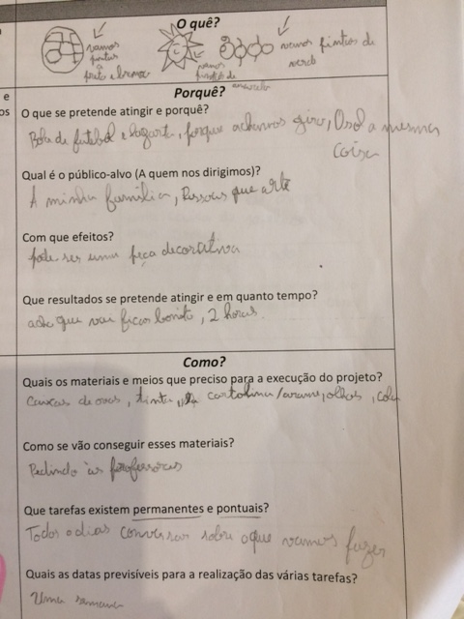 | Synthetic description.  "Make a bed" | Description of the idea, indicating the festive season of the year when it can be used.  “To make props for Carnival”
why?
What do you want to achieve and why? | They consider it to be a creative idea, as they are taking advantage of garbage.  “It's a creative idea, to make a tower out of garbage” | Listed the objects they intend to build | Do not respond | They say that their productions are for courageous people.  “We want to reach people with courage”
Target Audience | Define the target audience. | They define the family as a potential target audience. | Define the target audience. | Define the target audience.
With what effects? | Indicate the effects.  “To sell to people with a toy” | Indicate effects.  “It can be a decorative piece” | They do not indicate effects. | Indicate effects.  “Helping people to spend less money on Carnival”
What results and how long? They indicated what they intended to do and the time needed. | What results and how long? They indicated what they intended to do and the time needed. | They indicated their opinion on the aspect of the final work and the time required.  "I think it will be beautiful, 2 hours" | They indicated the belief that it would go well.  They indicated the number of days that would need “Good result, 30 days” | They did not indicate the intended results.  They indicated the number of hours they would need.  "2:00 pm"
How?
Which materials? | They indicated some materials. | They indicated some materials. | They indicated some materials. | They indicated some materials.
How to get the materials? | They indicated rules of good education.  “Asking teachers for permission” | They indicated the teachers. | They indicated the teachers. | They indicated rules of good education.  "Asking please"
One-off tasks and permanent tasks | They stated the objective.  "Make the tower" | They indicated a permanent task.  "Every day talk about what we are going to do" | They indicated a capacity that the Group must have.  “Be organized” | They indicate some tasks.  “Paint, draw and cut out”
Timetable | They assume that they can do everything on the day they completed planning. "today" | They indicate a scheduled date for completing the project.  "One week" | Indicate a scheduled date for completing the project. "May 28" | They assume that they can do everything on the day they completed planning. "today"

Appendice 7 – Compilation of children's drawings / diagrams with their created works
Groups | Schemes / drawings | Final Productions
Group1 | 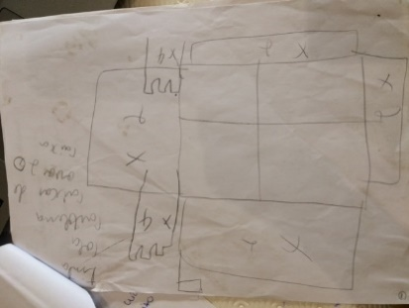m 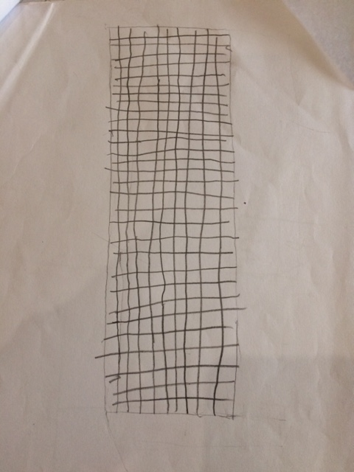 | 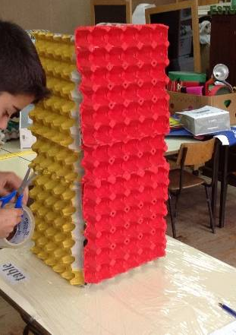
Group 2 | 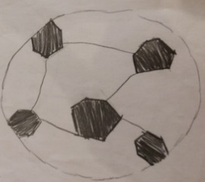  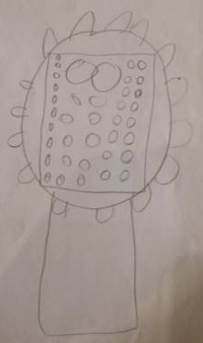  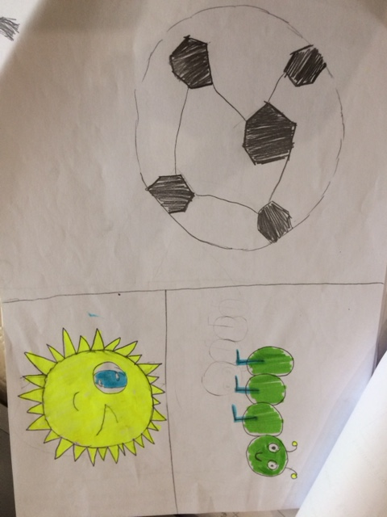  nm | 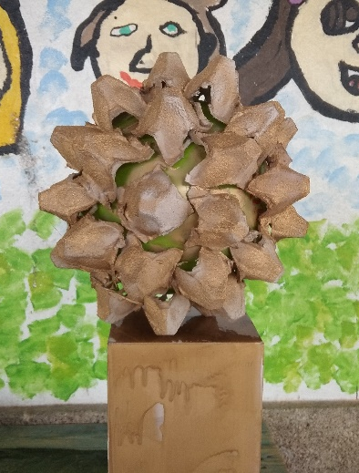  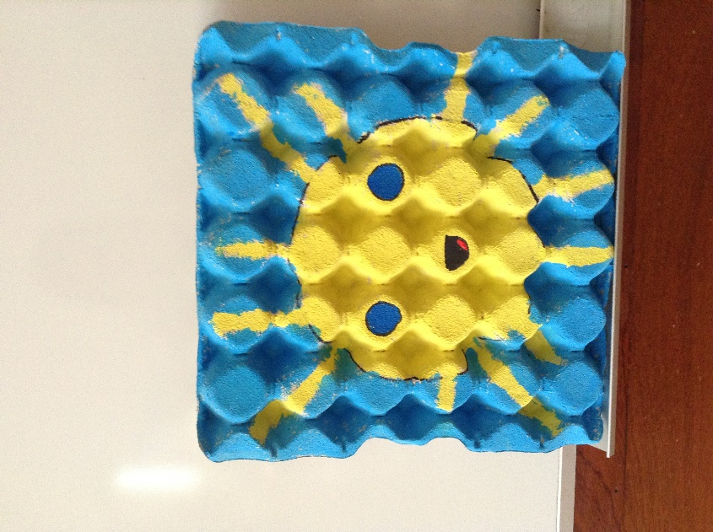
Group3 | 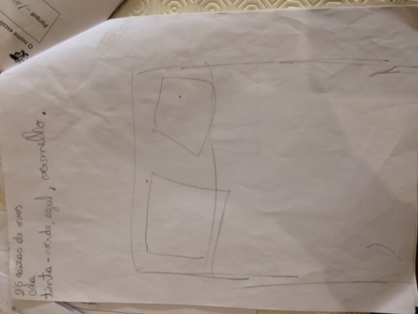m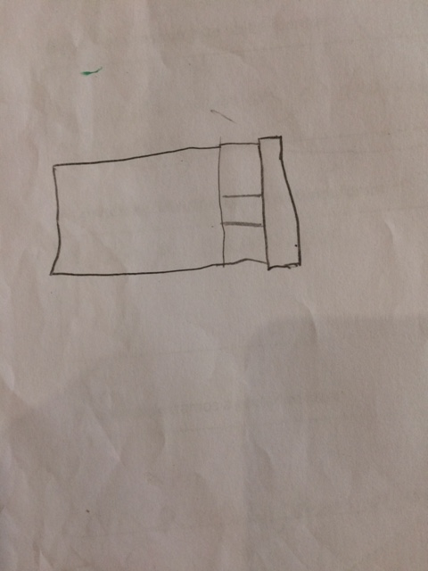 | 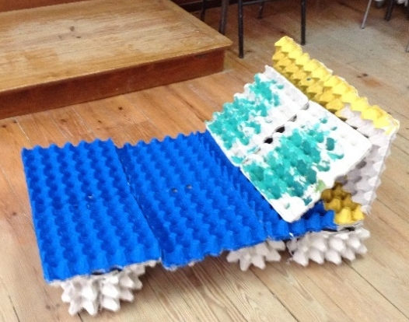
Group4 | 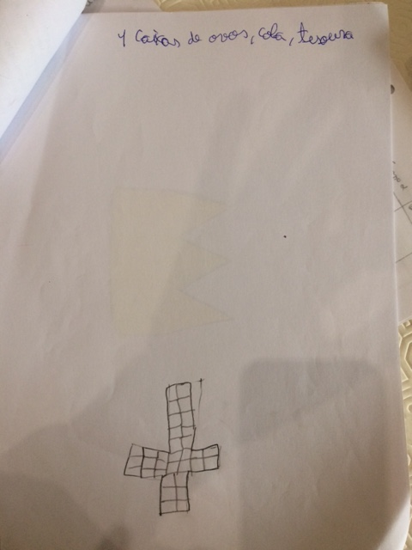n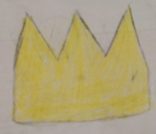n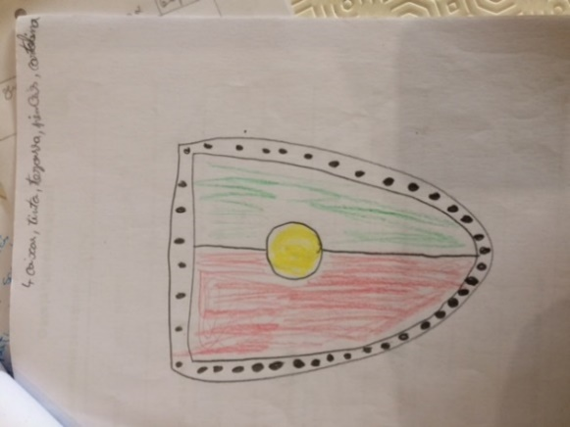n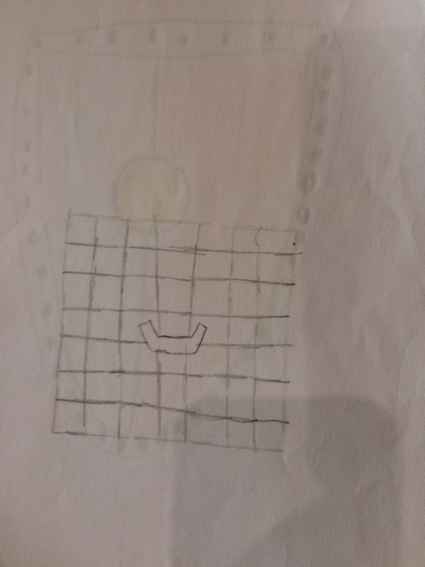 | 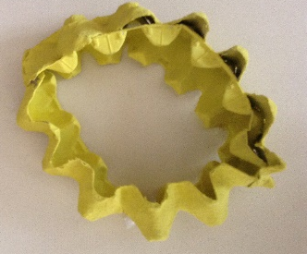  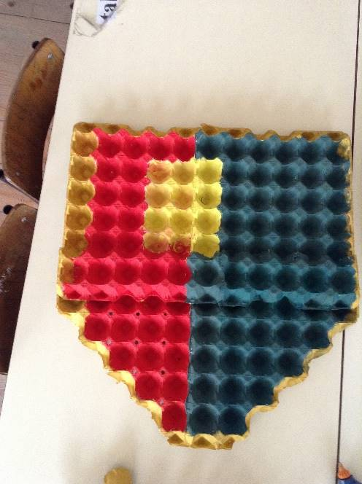  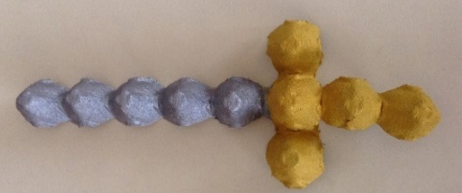

Appendice 8 – Project completion phrases prepared by the working groups
Groups | Phrases presented by groups
Group 1 | “Because we work hard and think our work is the most beautiful and takes care of the environment”
Group 2 | “Our works are the best because, the most creative in the entire universe and are made with garbage”
Group 3 | “Our work is the best because it is beautiful and environmentally friendly”
Group 4 | “Our works are the best because they are original, creative and phenomenal”

